

Volunteers’ Management System
Web Portal Installation Guide

Spring 2010

By:
Apollo Group

Table of Contents

Content Page #

Table of Contents 2
1 Introduction 3
1.1 References 3
1.2 Prerequisites 3
2 Deployment Procedure 4
2.1 Deploy web application 4
2.2 Deploy database 6
2.3 Configuring Database Connection 8
3 Verify Installation 8
4 Revision History 9

Introduction

This document will walk you through steps required to deploy Volunteers’ Management System Web Portal on the server. As it’s a server deployment which will happen almost once for each customer organization, it requires some technical knowledge.

References
In development of this document the content and/or concepts of the following resources have been used:

- Walkthrough: Deploying a Web Application Project Using a Web Deployment Package, http://msdn.microsoft.com/en-us/library/dd483479.aspx

Prerequisites
The following list itemizes some prerequisites for the server which the web portal should be installed:

- Microsoft Windows Server 2003 or higher with IIS 7 enabled
- ASP.NET 4 registered with IIS.
- Administrative rights
- Sql server 2005 or higher version accessible from server.

Deployment Procedure

To deploy the web portal on server perform the following steps:
- Deploy web application.
- Deploy database.
- Configure database connection.

Deploy Web Application
- Extract the zip file delivered with software package in a folder on the server’s local hard drive.

- In Windows Control Panel, click Administrative Tools, and then click Internet Information Services (IIS) Manager.
IIS Manager dialog opens and Server Name is selected in the Connections panel.

- In the Connections panel, expand the node for Server Name, expand the Sites folder, and then select Default Web Site.

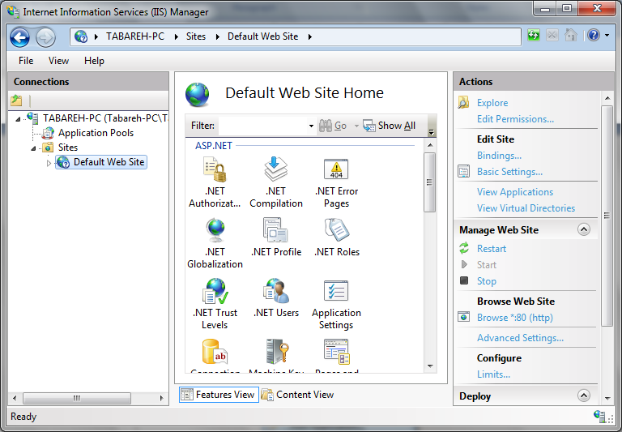

- Right click on Default Web Site and choose Add Application.

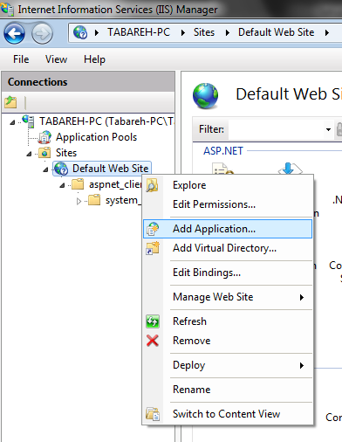

- Add Application dialog opens. Enter a unique name in Alias. The website will be accessible through this name later. Choose “ASP.NET v4.0” as Application pool. Also for the Physical path, select the folder on server’s local hard drive when you extracted the zip file delivered with software package. Press the OK button.

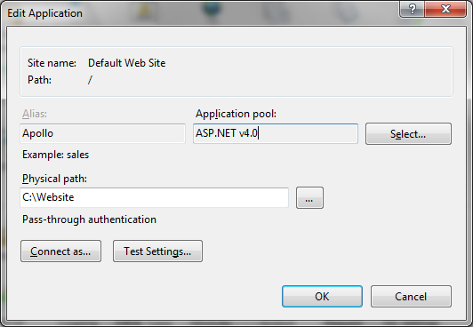

Web application is added successfully and you can see it as a node under Default Web Site node.

Deploy Database

If you browse the folder where you extracted the installation package, you’ll find a file named Apollo.bak this is the file which should be deployed on database server by following the following steps:

- Open SQL Server Management Studio and connect to the server you want to deploy the database and expand the server node of the left-hand tree view. You will have a window like the following illustration:

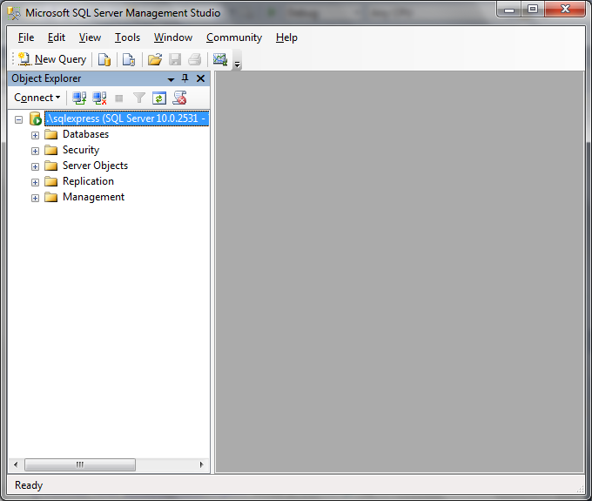

- Right click on Databases node and select Restore Database

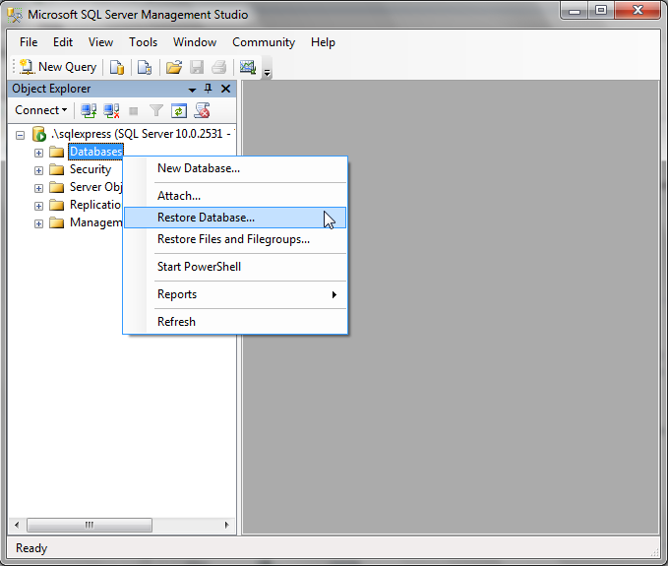

- The Restore Database window opens. Type Apollo in the To Database field and choose the Apollo.bak file as the backup set to be restored. You will have a screen like the following illustration.

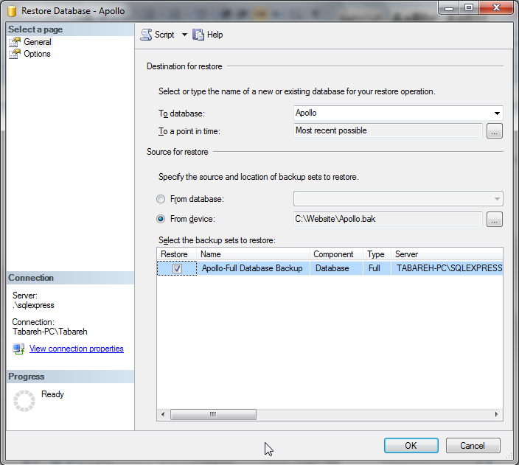

- Be sure that the item Apollo- Full Database Backup is checked and then press the OK button. The database will be restored, a success message will be shown, and you can explore the Apollo database using the left-hand tree view.

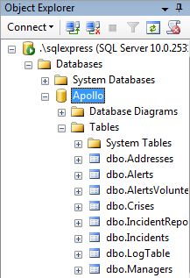

Configuring Database Connection
In this part you’ll set the configuration needed to provide the connection between web application and database.

- Explore the folder which contains the extracted files of the software package and find the file named “web.config”. Open this file with a plain text editor like windows notepad and search for the following text:

<add name="ApolloEntities" connectionString="metadata=res://*/DataModel.csdl|res://*/DataModel.ssdl|res://*/DataModel.msl;provider=System.Data.SqlClient;provider connection string=&quot;Data Source=129.16.213.108\SQLEXPRESS;Initial Catalog=Apollo;Persist Security Info=True;User ID=apollo;Password=apollo;&quot;" providerName="System.Data.EntityClient"/>

- To establish the connection, it’s needed to change the highlighted part of the code above with the database server which you used for deploy database
- Save and close the file.

Verify Installation

The final step is to verify that the web portal is deployed successfully. To do that, perform the following steps:

- Open a browser and enter the following URL:

http://localhost/apollo

The Default.aspx page is displayed

- Click the Log In link.
- Enter Administrator username and password which you have received confidentially.

If the login is performed successfully, you will get a message which informs you about it. If not, call system support centre.

Revision History

Name | Date | Reason for Changes | Version
Abdollah Tabareh | 14 May 10 | Created first draft | 0.1
Waseem Soomro | 14 May 10 | Review | 0.2

